Subject: Compiler Construction

Quiz 03

Time allowed: 50 minutes

Dated: Nov 18, 2019

Attempt any three questions

1. State specifically where and how *follow(α)* function is used in parsing and calculate the set of follows for the grammar

S 🡪 AA

A 🡪 aA | b

1. Discuss what are *LR(0) items* and *closure* also construct a DFA for the items of below grammar

S 🡪 AA

A 🡪 aA | b

1. Construct a parsing table for the grammar and automaton used in question 2.
2. 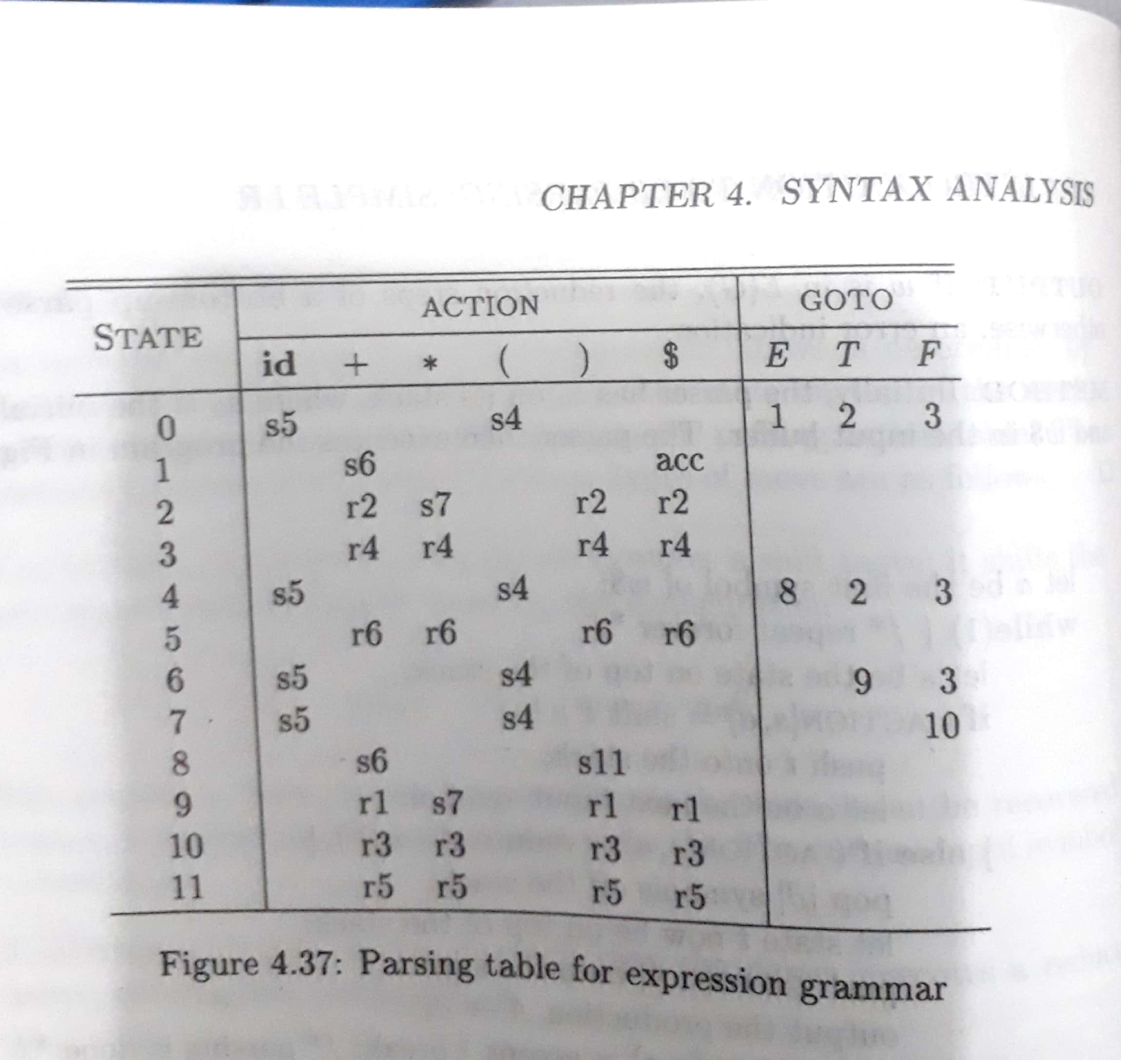Consider the Grammar and it parsing table

E 🡪 E + T | T

T 🡪 T \* F | F

F 🡪 id | (E)

Draw the parse tree for the syntax (id+id) using SLR parsing technique.